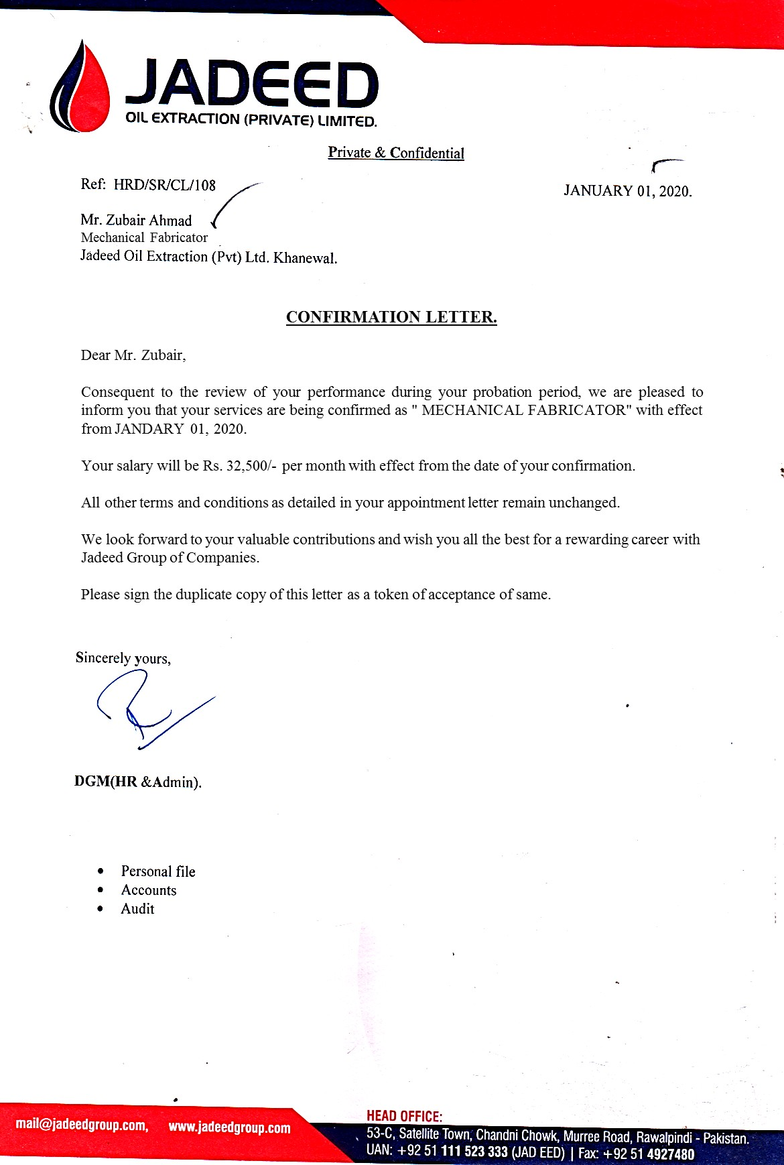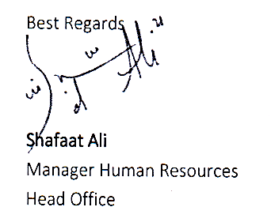

**Ref:-AS-887-01 Date: <To>**

TO WHOM IT MAY CONCERN

This is to certify that Mr. **<Name>** S/o **<fname>** have NIC No: **<CNIC>** has worked in our organization from **<From>** to **<To>**  as **<Designation>** at Jadeed Oil Extraction Pvt Ltd., Khanewal.

During the above mentioned period he has been found to be obedient hard working and develop flow to the job what so ever assigned to him by the company

He bears a good moral character.

We wish him every success in his future life.

Peronal File: 000154 (12456)